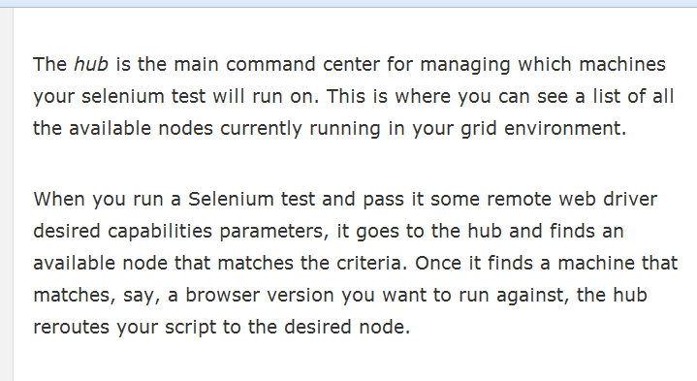

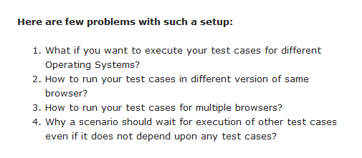

Step 1: Command to start the hub:

Java –jar selenium-server-standalone-2.53.0.jar –role hub

(FYI — your version number may be different than mine

Imp: Here J is capital in Java-jar).

After running the command, it will look like below:

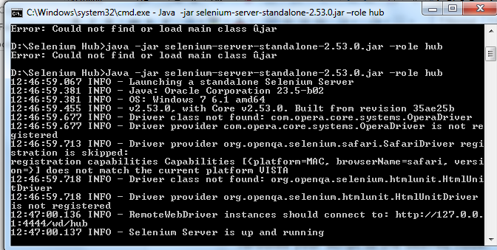

Server is now started and listening to default port i.e. 4444

Step 2: Now open a browser and navigate to <http://localhost:4444/grid/console>

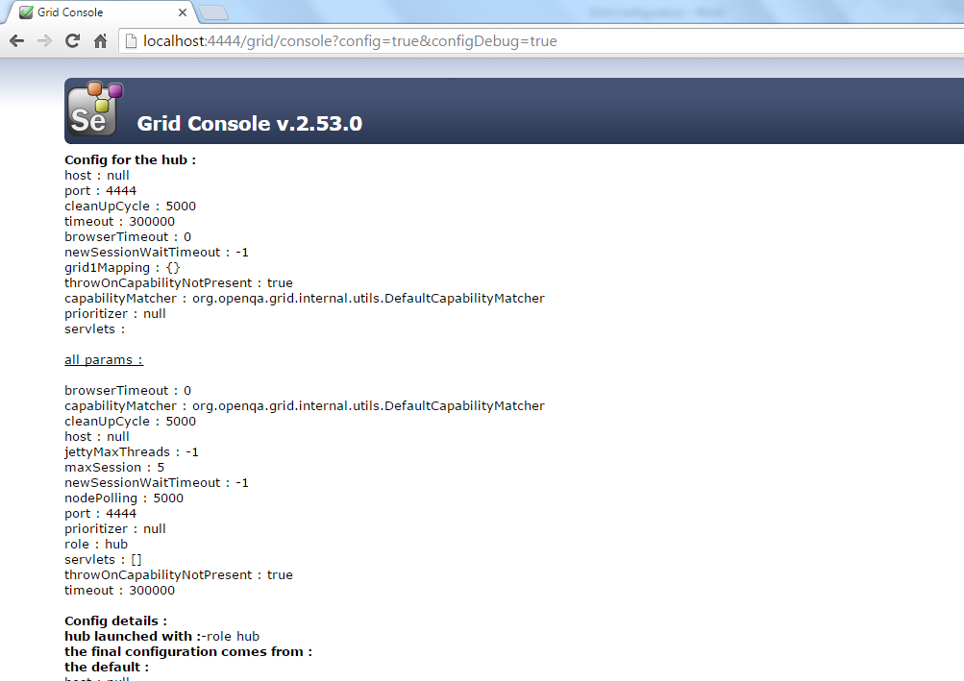

Note: In case, any error occurs during opening of <http://localhost:4444/grid/console> that means 4444 port is already occupied and need to kill that process which is occupying that port.

Solution: Open task manager and kill all chrome processes or restart the system.

Following command can be used to kill the ongoing console session:

<http://localhost:4444/selenium-server/driver/?cmd=shutDownSeleniumServer>

**Issue:**

**In case, sometimes, multiple instances of browser such as firefox** , chrome and ie can open instead of one browser instance. So in order to avoid that situation, in the testng.xml use “parallel=methods” instead of parallel =”tests’ as highlighted below:

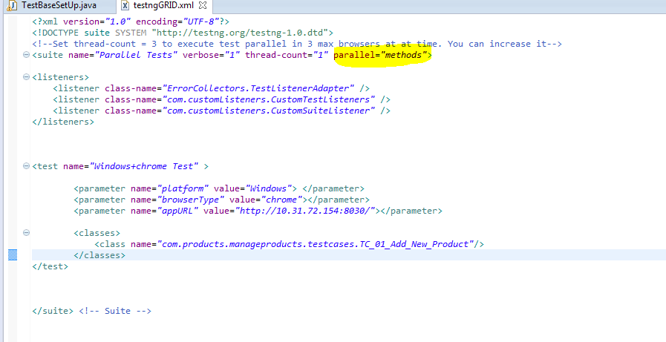

Issue: What if firefox crashes or start behaving unexpectedly then there is a problem that firefox process is not killed properly. So we have to kill it manually. Follow the below steps:

Step:

1. Open cmd prompt.
2. Enter tasklist and press enter.
3. Type "taskkill /IM firefox.exe /F" to the right of the command prompt and then press "Enter." This kills all running Firefox processes on the computer.

Issue: Even though everything looks good to run tests parallel but still running it in a sequence means only browser is opening at a time.

Solution: Update testng. Xml file by updating parallel attribute as “tests” not method.

